UNIVERSITY OF INFORMATION TECHNOLOGY

**FACULTY OF COMPUTER ENGINEERING**

--------------------------------



**VERIFY EMBEDDED SYSTEM ON SoC**

**INTERNSHIP REPORT**

Student Name: HUYNH NHAT QUANG

Student ID: 13520673

Class: MTCL2013

Supervisor: TRAN NGOC DUC

*Ho Chi Minh City - 2016*

**PREFACE**

For the purpose of helping students be more familiar with the working environment in the company and know how to apply the theories which they have learnt in university into practice, internship is a very useful subject. During the ten-week internship at Renesas Design Vietnam Co., Ltd, I have received enthusiastic support from friendly colleagues in the company. Therefore, I would like to express the most sincere gratefulness to the company.

On the other hand, I would like to thank all the teachers of the Faculty of Computer Engineering, who gave me a great deal of useful knowledge that has helped me a lot when we apply in real situation in this practicum. I also would like to thank my instructor Mr. Tran Ngoc Duc who have supported and guided me through this internship.

Moreover, I would like to show appreciation to the company’s Board of Directors who have facilitated me in order to help us make efforts as much as I can to complete the internship successfully.

Last but not least, I express gratitude to Mr. Le Dang An Hue - my experienced mentor and all of the colleagues in the company for helping me complete the internship.

*Ho Chi Minh City, August 8th, 2016*

The internship reporter

Huynh Nhat Quang

**INSTRUCTOR COMMENTS**

Comments:

……………………………………………………………………………………………………………………………………………………………………………………………………………………………………………………………………………………………………………………………………………………………………………………………………………………………………………………………………………………………………………………………………………………………………………………………………………………………………………………………………………………………………………………………………………………………………………………………………………………………………………………………………………………

Mark:

Date: …………………………..

Instructor

**TABLE OF CONTENTS**

CHAPTER 1: OVERVIEW OF THE INTERSHIP COMPANY 6

*1.1. General Information 6*

*1.2. History of company 6*

*1.3. Scope of activities 8*

*1.4. Organizational Structure 8*

*1.5. The branch 9*

*1.6. Achievements 8*

CHAPTER 2: PRACTICE CONTENTS 11

*2.1. Job Description 11*

*2.2. Working method 12*

*2.3. Workflow and Result 13*

*2.3.1 Investigate Integrated Development Environment (IDE) 13*

*2.3.2 Investigate Auto Testing Tool 14*

*2.3.3 Execute Basic Test Project 16*

*2.3.4 Set up auto test environment 16*

*2.3.5 Create script from PCL (Program Check List) 17*

*2.3.6 Execute test cases base on test specification 18*

*2.3.7 Wrap up 19*

CHAPTER 3: ACHIEVEMENTS 20

*3.1. Consolidated knnowledge 20*

*3.2. Additional practical knowledge 20*

*3.3. Reality experiences 21*

CHAPTER 4: CONCLUSIONS AND RECOMMENDATION 22

*4.1. Conclusions 22*

*4.2. Recommendation 22*

REFERENCES 24

# **CHAPTER 1**

# **OVERVIEW OF THE INTERSHIP COMPANY**

## **General Information**

Renesas Electronics Corporation, the world’s number one supplier of microcontrollers, is a premier supplier of advanced semiconductor solutions including microcontrollers, SoC solutions and a broad range of analog and power devices. The company's head office is located in Japan and this company currently has business activities in nearly 20 countries around the world.

Renesas Design Vietnam Co., Ltd. (RVC) belongs to Renesas Electronics Corporation, which is located in Ho Chi Minh City and has a function of designing and developing hardware, software for cars and digital equipments. RVC is nationally recognized as the first company in the field of semiconductor tech which was established in Vietnam.

## **History of company**

Renesas Technology Corporation was founded in January 4/2003 by the union of the two fragments of the processor Hitachi, Ltd. and Mitsubishi Electric. In April of 2010, Renesas Technology Corporation combined with NEC Electronics Corporation and renamed to Renesas Electronics Corporation. It is a multinational company and has eight subsidiaries in Japan and 23 subsidiaries in nearly 20 countries around the world. Renesas Electronics Corporation is headquartered in Chiyoda district, Tokyo, Japan, with a total employees of more than 27,000 people (8/2014). The company is one of the largest manufacturers of semiconductors in the world, which ranks first in the production of microcontrollers and ranks second place in the production of the application processors worldwide.

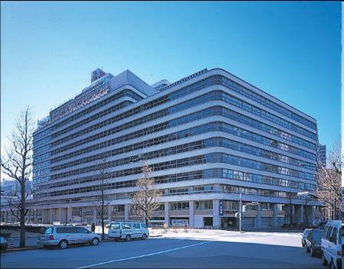

Figure 1: Renesas Electronics Corporation Headquarters in Japan

(Source: wikipedia.com)

With 100% investment of Renesas Electronics Corporation (Renesas Technology Corporation at the time), Renesas Design Vietnam Co., Ltd. (RVC) was established on October 5, 2004, and is nationally recognized as the first company in the field of semiconductor technology in Vietnam. The role of the company is doing research, designing and developing hardware (IC) and functional software for semiconductor IC (integrated circuit).

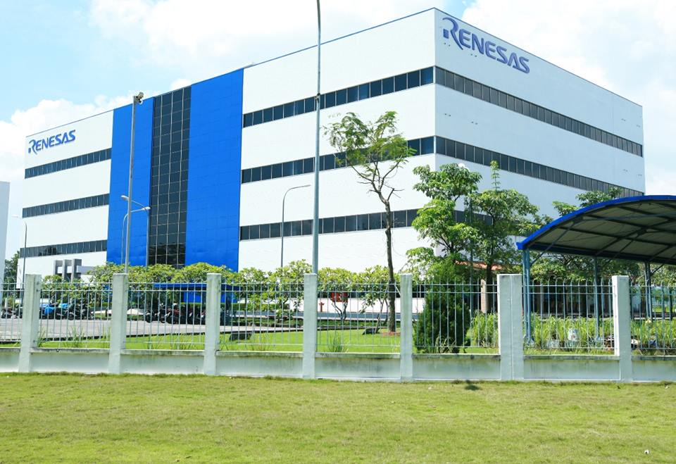

Figure 2: Renesas Design Vietnam

(Source: facebook.com/RenesasDesignVietnam)

## **1.3. Scope of activities**

Currently, the company's business activities consist of two main areas: hardware and software.

In terms of hardware, RVC makes a process on designing and developing advanced hardware, including RTL design, test (Verification), compile (Synthesis), placement and routing (Place & Route). Some research subjects in the field are microcontrollers, microprocessors and integrated circuits for systems of multimedia entertainment.

In terms of software, RVC designs and develops embedded software, as well as tests and evaluates software based on the reference system, develops and integrates software modules based on customers’ requirements.

## **1.4. Organizational Structure**

**Technology development department**

**Hardware**

**Software**

**Human Resources**

**Accounting department**

**IT**

**Facilities management**

Figure 3: Structure of the RVC

The organizational structure of the company includes many parts and these parts are linked with each other. HR department is responsible for organizing, recruiting, and human resources management of the company. Accounting department analyzes business results of enterprises, and makes budget plans for the company. Facilities Management Department is responsible for managing the activities happening in the building of the company such as security, sanitation, food, electrical system maintenance...

The technology development department which develops hardware and software has an engineer team. IT department is responsible for maintaining the computer systems of the company intranet.

## **1.5. The branch**

RVC now has only one branch in Vietnam, located in Lot 29-30-31a, Tan Thuan Street, Tan Thuan Export Processing Zone in District 7, Ho Chi Minh City.

## **1.6. Achievements**

For nearly 10 years, RVC has made ​​important contributions to the development of the corporation as well as the outstanding contribution to the society, contributing to changing the face of Ho Chi Minh City in the area of ​​ semiconductors technology. The objective of RVC is always maximizing customers’ satisfaction with the most modern technology.

Being one of the most important designing centers in the world, RVC constantly improves the quality of a team of nearly 500 engineers and it is striving to reach 1,000 engineers in the coming years. With basic trainings, RVC ensures the available ability of new engineers. Moreover, for developing workforce, senior engineers of the RVC will have a chance to participate in the training session to enhance knowledge, project management skills, soft skills ... In addition, thanks to a professional modern working environment, the employees can catch up with the most advanced trends of technology available all over the world.

During its development, RVC has contributed to social and financial aspects of the country. Every year, the company has always had humanitarian blood donation, scholarships, gifts to troubled places ... The "Day for the community" is a typical example for a blood donation campaign.

Another achievement of RVC is the collaboration with universities in Ho Chi Minh City. By conducting seminars or the funded experiments, RVC has specialized knowledge of the students as well as the quality of the future workforce. RVC also has sponsored for the contest MCR (Micom Car Rally) and received a positive response as well as enthusiastic participation of the students in some universities such as University of Ho Chi Minh City University of Natural Sciences, HCMC. Through this contest, students will be able to understand more about advanced programming techniques and the relationship between theory and practice. RVC also holds annually practicum to help students understand the real working environment and helps them to have the opportunity to apply theory into work.

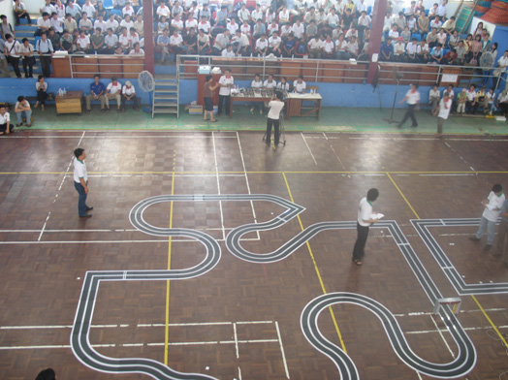

Figure : The contest Micom Car Rally was held at the University of Natural Sciences, HCMC

*(Source: http://www.hcmus.edu.vn/)*

Because of the above achievements, the RVC has been awarded many awards recognizing its outstanding contribution to the development of the city.

**CHAPTER 2**

**PRACTICE CONTENTS**

**2.1. Job description**

In a period of ten weeks at RVC, I am a member of testing team, to conduct full development and verification for Renesas IDEs. Content, timing and outcomes which are achieved by the students in 10 weeks are divided in the following table:

|  |  |  |  |  |
| --- | --- | --- | --- | --- |
| Task | Date Start | Date End | Result | Status |
| Investigate Integrated Development Environment (IDE) | 14/06 | 17/06 | Summary Slide (e2 studio )  Practice (Build, Debug project) | On-time |
| Investigate Auto Testing Tool | 20/06 | 24/06 | Summary Slide  Practice | On-time |
| Execute Basic Test Project | 27/06 | 22/07 | Practice (Basic_Test Project)  Test Report | On-time |
| Set up auto test environment | 18/07 | 25/07 | Practice (run on Linux environment) | On-time |
| Create test script from PCL (Program Check List) | 28/07 | 01/08 | Test Script  Test report | On-time |
| Execute test cases base on test specification | 01/08 | 12/08 | PCL + test result  Test report | On-time |
| Wrap up | 15/08/2014 | 19/08/2014 | Presentation | On-time |

## 

## **2.2. Working method**

The student’s working method during the internship is mostly self-control, including researching materials and performing assigned work. After the completion of each task, the group will have meetings to review and evaluate student’s report. Student has to send weekly reports of the tasks performed during the week to project leader, and the progress of the mission next week.

Daily report as following:

**[Issues & Problem]**

(describe difficulty or problem)

- problem

- cause

- solution

**[Activities]**

Task name

- Output :

- Deadline :

- Status : xx%

- Health : On-time/Advanced/Delayed

- Comments : note (completed/remaining items)

**[Action items]**

Task name

- Output :

- Deadline :

- Expected progress : xx%

**[Information]**

Anything which may affect to your work: Technical Training, day off...

In addition, the group will have a meeting for leader to announce important news, and review what members have done in the past week, give suggestions and classify the job for members in the next week

**2.3. Workflow and Result**

**2.3.1 Investigate Integrated Development Environment (IDE)**

* Duration: 1week
* Task Description:
  + Basic understand about e2 studio
  + Execute debug with emulator and device
* Input:
  + e2 studio package
  + User guide document
* Output:
  + Report of e2 studio overview
  + Presentation in review meeting
* Detailed Work:
  + Renesas eclipse embedded studio, known as e² studio, is a complete development and debug environment based on the popular Eclipse CDT project. Essentially open source, the Eclipse CDT covers build (editor, compiler and linker control) as well as debug phase based on an extended GDB interface.

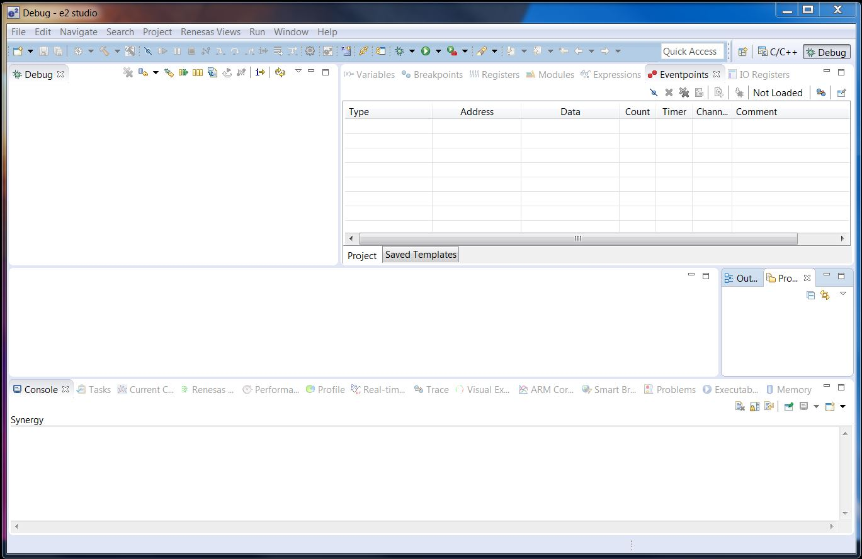

* + The student needed to investigates e2 studio, which is the main application under test. In detail, student learnt how to create, build and debug a project in two modes Simulator Debug and Hardware Debug. Besides that, student investigated 6 common views in Debug Perspective: Trace, Profile, Real-time Chart, Performance Analysis, Renesas Coverage, Visual Expression.
  + After complete investigate, student had to make a report for confirm understanding with mentor and prepare a presentation in a meeting review

**2.3.2 Investigate Auto Testing Tool**

* Duration: 1 weeks
* Task Description:
  + Research usage of new auto testing tool
* Input:
  + Materials for auto testing tool
* Output:
  + Report of understanding
  + Sample auto test script
* Detailed Work:
  + Auto Testing Tool is a project for GUI testing automation of Eclipse-based applications. This auto testing tool is fully aware about Eclipse Platform's internals, hiding this complexity from end users and allowing QA engineers to create highly reliable UI tests at great pace.
* The student was assigned to investigate auto testing tool to improve the productivity of testing by change from manual to automatic test. Then, student wrote an instruction document auto testing tool

**2.3.3 Execute Basic Test Project**

* Duration: 3 weeks
* Task Description:
  + Using Auto testing tool to verify execution of e2 studio
* Input:
  + e2 studio and Auto Testing Tool document
  + e2 studio
  + Auto Testing Tool
* Output:
  + Requirement Specification and User manual for Project
  + Auto Script
* Detailed Work:
  + In this project, student worked in group of two.  During the progress, student received the requirement and comment from mentor to optimize productivity.
  + The requirement of this project is to verify the basic function of e2 studio: Create, Build and Debug Simulator with all devices and toolchains.
  + The outputs of project include auto script, requirement specification and user guide.

**2.3.4 Set up auto test environment**

* Duration: 1 weeks
* Task description:
  + Understand how to use auto test on other environment (Linux, Windows)
  + Understand how to set up environment to run auto test.
* Input:
  + User guide line about to set up environment
* Output:
  + Summary Slide
  + Set Up Process Report
* Detailed work:
  + Run auto test on Linux and Windows 10
  + To learn how to use auto test on other Environment, in 1 weeks, I was assigned to investigate how to setup auto test on Linux Environment and compare with setup on Windows 10 Environment
  + First change advance system setting and display setting follow instruction from user guide line
  + Then set up auto test and verify step by step. If found the wrong step, note that then reply on Test report
  + After finished setting up, run auto test and verify that run correctly. If this has any problem, I will try to solve this and write how to fix to Test report.
  + The major purpose of this work is :
    - To understand test environment construction.
    - Understand how to set up and run test on other environment
  + Result of this task is summary slide which describe how much I understand after done this task and Test report

**2.3.5. Create script from PCL (Program Check List)**

* Duration: 1 week
* Task Description:
  + Create auto test scripts for test cases from PCL as customer request
  + Verify if these test case can run correctly
  + Check result to Program Check List
  + This is the real project from Japan
* Input:
  + Program Check List
  + Windows 7 64 bit
  + Board
* Output:
  + Test Script
  + Test Report
* Detailed Work:
  + Read PCL carefully to understand what I need to do. If some description is so hard to understand, I will ask my mentor for help
  + Run these test cases manually follow test case description. Verify if these test cases can run correctly, then check to PCL
  + Write test script to do these test cases automatically. Run auto test case and check to PCL if this can run and don’t have any issues
  + Write Report how many test cases was done, how many test case can do automatically and how many test case can’t be done

**2.3.6. Execute test cases base on test specification**

* Duration: 1 week
* Task Description:
  + Create test case from test specification
* Input:
  + Test specification
  + Window 10 Environment, Linux Environment
  + Board
  + This is a real project which I do with my group
* Output:
  + PCL and test result
  + Test Report
* Detailed Work:
  + Read test specification carefully understand test case description and list Indispensable e2 studio tools and file
  + Try to run these test cases manually as test case description. If these test case description have any issues, I will try to fix this and report in Test report about these issues
  + Write auto script to do these test cases automatically. Verify if these auto test cases run correctly.
  + Write information about this test as result, name of tester, how to test this test case (auto, manual…)
  + Report to my mentor about this

**2.3.7. Wrap up**

* *Duration: 1 week*
* *Task description:* 
  + Prepare Internship Completion Presentation
* *Input:*
* *Output:* 
  + Presentation
* *Detailed work:*
  + At the end of internship, I have to make an internship completion presentation. I have to make a ten-minute presentation to present to the company’s leadership, managers and mentors. The presentation has to include my assigned tasks and projects as well as the difficulties I have to face with, how I overcome these troubles and what I have learnt from the internship period.

**CHAPTER 3**

**ACHIEVEMENTS**

**3.1. Consolidated knowledge**

During the internship, my work contains testing project on e2 studio using Auto Testing Tool, using Linux OS mechanism and command languages. I can apply my knowledge about Linux OS that I have learnt from Operating System course at university.

In addition, I spent most time with Eclipse Command Language which base on Java programming language. It helps me to improve my programming skill so much.

Last but not least, testing on RX devices is a good opportunity for me to practice and improve my embedded knowledge I got from Embedded System minor which will help me on my future career

**3.2. Additional practical knowledge**

During the internship, I faced a new phase that I haven’t done at university. It is the Test Phase. I need to do Test Phase to get test specification. I help me know more a about testing process which I haven’t learnt from university. It helps me avoid many bugs and makes Implementing Phase easier.

Moreover, the Testing Phase in RVC is quite helpful, too. I get general idea about the organization of testing job through PCL. I also learned how to write test script to do my test automatically, to reduce workload.

Finally, practical knowledge is also attained when I create startup codes for RH850 devices. To test my startup codes, I need to write my own linker directive files. I also need to flash my executable file to a real board using command line.

**3.3. Reality experiences**

During the process of working at RVC, I have improved in both technical skills and working skills. I could understand more and experience in testing field, at the same time, professional working style, self-planning, report skill… also the important thing that student were achieved. Moreover, Internship program gave student the motivation and orientation for the future career.

**CHAPTER 4**

**CONCLUSIONS AND RECOMMENDATION**

**4.1. Conclusions**

After ten weeks of Internship at the company, it has helped me not only to apply knowledge I have learnt at university into the job but also to know more useful knowledge for my future career. Besides, work-style and policy in a professional environment such as RVC is very important things which I can learn.

**4.2. Recommendation**

In terms of Internship Company, from my view point, the content of the internship program is practical and realistic which will help internship have the opportunity to get experience with the working environment, put the theories which they have learnt from universities into practice as well as prepare for the future career. I highly recommend that the company should maintain this internship program in the following years

In terms of the university, I think that the knowledge which I was taught in the university is effective and help me a lot on applying in realistic jobs. Therefore, there still have some different between theoretical and practical skills. I recommend that our university should organize more practical soft skills class and working skills so that students can have a general view point in a working environment

Therefore, there is still a limitation in collaboration skills and the connection of theoretical and practical skills. I recommend that our university should organize more thematic sessions introducing and training soft skills as well as working skills so that students can have a general knowledge about real working environment. I also recommend that university should add more realistic practical courses in training courses in order not to know the useful of theory in reality but also create more interesting and eagerness for students

For the internship process, in my opinion, there should be more opportunity to get more training after internship, so students can learn more from work in order to get more working experience

**REFERENCES**

[1] Renesas Website

https://www.renesas.com/en-sg/about/company.html

[2] RVC Website

http://vietnam.renesas.com/about/

[3] Eclipse Website

http://www.eclipse.org/